**KENYA SCHOOL FOR INTEGRATED MEDICINE NEWSLETTER**

Year 8, number 17, December 2013

Dear all,

This week our students are concentrating on their Continuous Assessment Tests just before the School will close for Christmas holidays and will reopen on Monday 6th of January 2014.

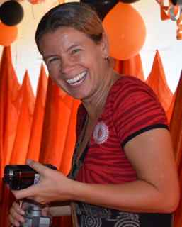Due to the wonderful help of Jane, we have been able to restructure several departments within the Centre. We are very happy with this strong cooperation and like to thank her for her effortless hard work!

The past 6 months were as busy as ever full of events and great developments. We are very pleased to partner with the Ministry of Health and look back to a successful Jigger Campaign and interesting World AIDS Day 2013.

In October we had our 4th Graduation, which was a big success and attended by 400 guests.

We have had also some interesting Nutrition Days and busy mobile clinics.

One of our graduates of 2011 has now opened her own clinic in one of the private hospitals in Mombasa and this makes us very happy because it’s an important step forward.

On behalf of my Board, students & staff, I wish you a Merry Christmas and Happy New Year!

Marie Magré, team & students

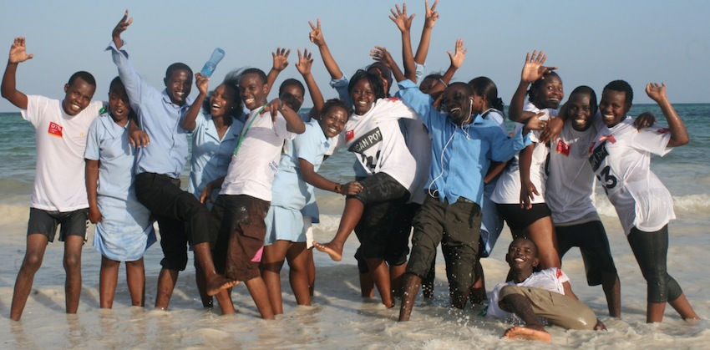

**MOBILE CLINCS – JULY AND AUGUST 2013**

We have been carrying out several outreaches with our students, homeopaths and clinical officer to Tiwi, Perani and Shimba-hills and Mivumoni. We were able to treat hundreds of people in these remote areas with mostly skin conditions, chest pains and abdominal complaints. Young mothers mainly visit these mobile clinics with their children.

---------------------------------------------------------------------------------------------------------------------------

**START NEW ACADEMIC YEAR – SEPTEMBER 2013**

We kicked off the new academic year with 16 new students and are pleased to see they have all settled in nicely into their new environment. Thanks so much to homeopath Rebecca from New Zealand for your great teaching and we are sure they all will become excellent homeopaths!

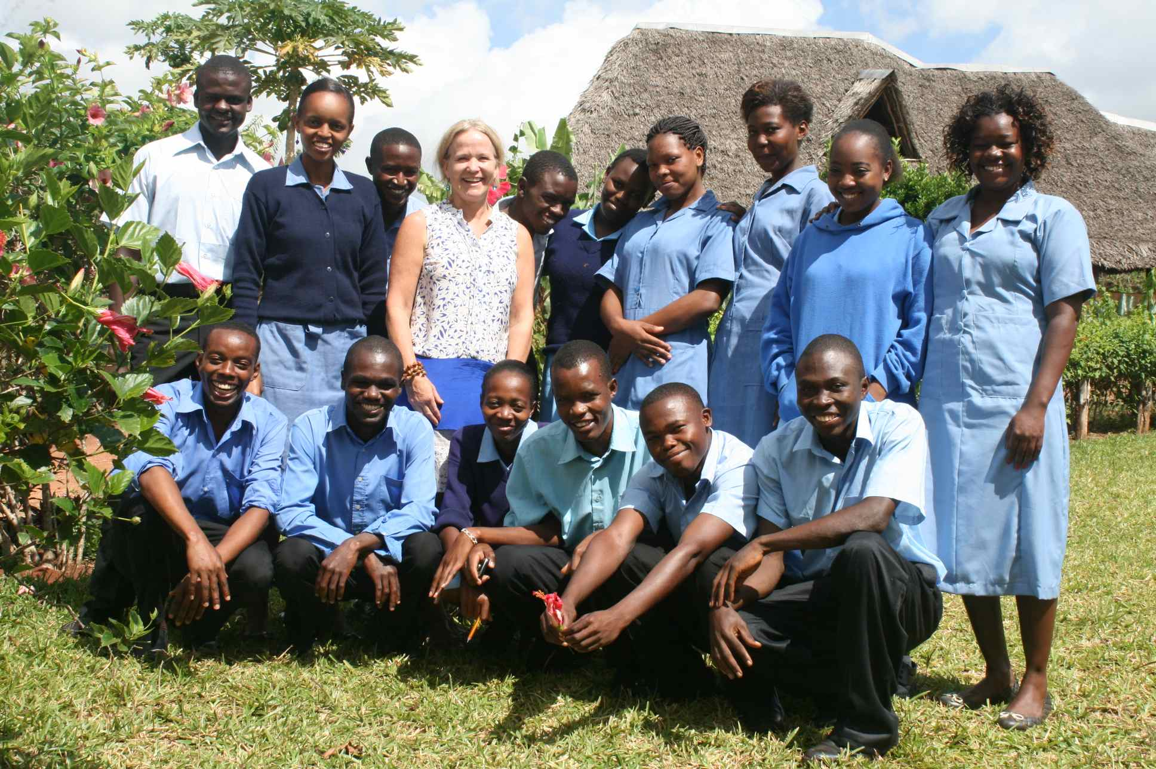4Kenia is still looking for 4 sponsors who are able to assist them during the 3-years full time Diploma Course. You can make a choice from below options which sponsorship suits you best. You can even share your sponsorship with friends or colleagues!



**VISITING LECTURERS & FRIENDS**

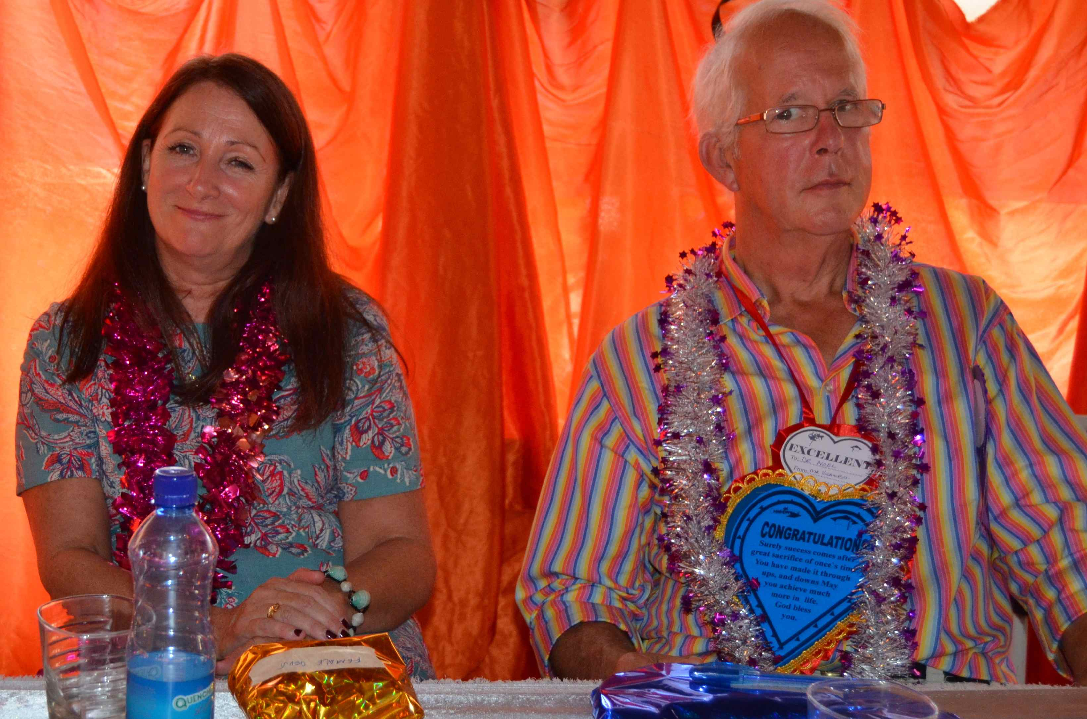

Nursing Dean Mrs Patricia Donnachie and Doctor Noel Thomas were again of great help during the oral examinations of the third year students who all graduated in October.

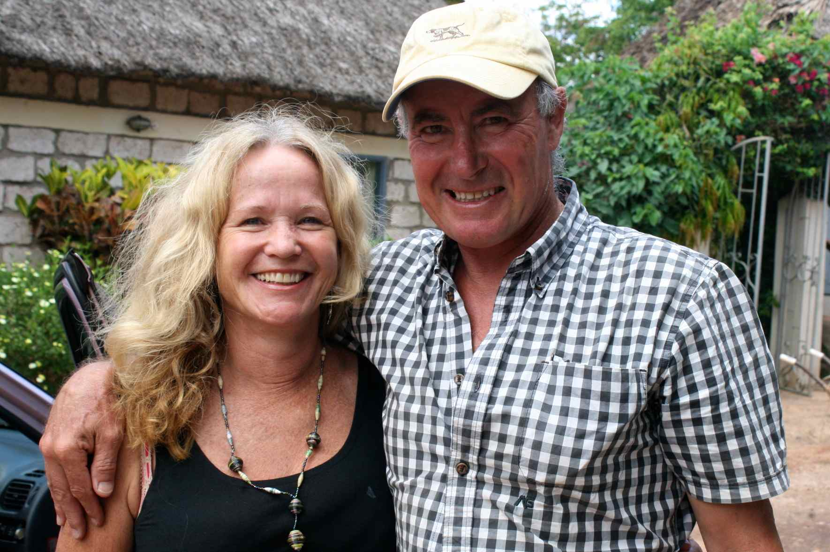

Experienced homeopath Rebecca & her multi talented husband Brett from New Zealand assisted us during the busiest period of the year. Brett was in charge of the main shopping, our driver and also carried out some plumbing work….

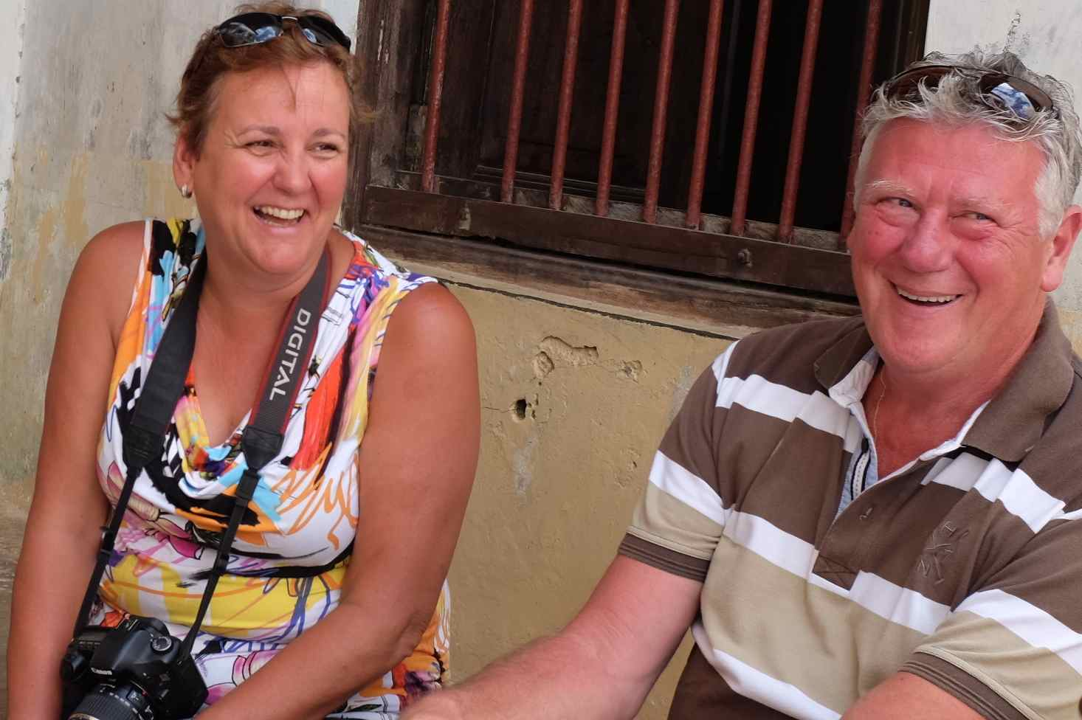

John & Marijke from Stichting Lelystad Helpt Kenia have been of great help.

John has designed and updated our tailor made students-database for the school and Marijke helped us again with our financial administration and took many beautiful pictures from our students during several activities.

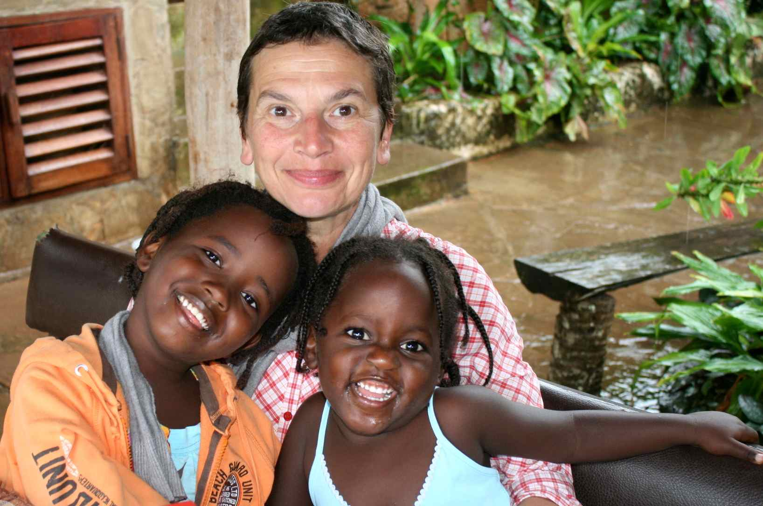

Italian Homeopath Alina with her two best friends.

Alina has been teaching both our first and second year students, where she combined her creativity and psychological insights into inspiring lessons for the students.

**4TH GRADUATION – OCTOBER 2013**

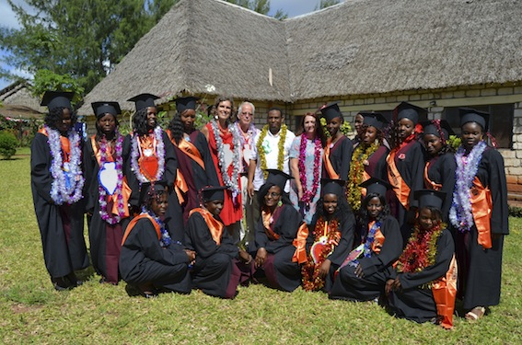

Health Minister of Kwale County Dr. Athuman Chiguzo gave a very promising speech and invited all the graduates to come for an interview to his office to start working within the public hospitals of Kwale County. We wish to thank him for his fantastic support and cooperation!

Already out of the 15 graduates who finished in October, three graduates are active in public Hospitals, while others are working in Voluntary Counselling & Testing Centres. One of our graduates Irene has gone back to Tanzania as a professional homeopath to assist our colleagues Jeremy & Camilla at their wonderful project “Homoeopathy for Health in Africa”.

---------------------------------------------------------------------------------------------------------------------------

**HIV AIDS TESTING AND COUNSELING COURSE - OCTOBER**

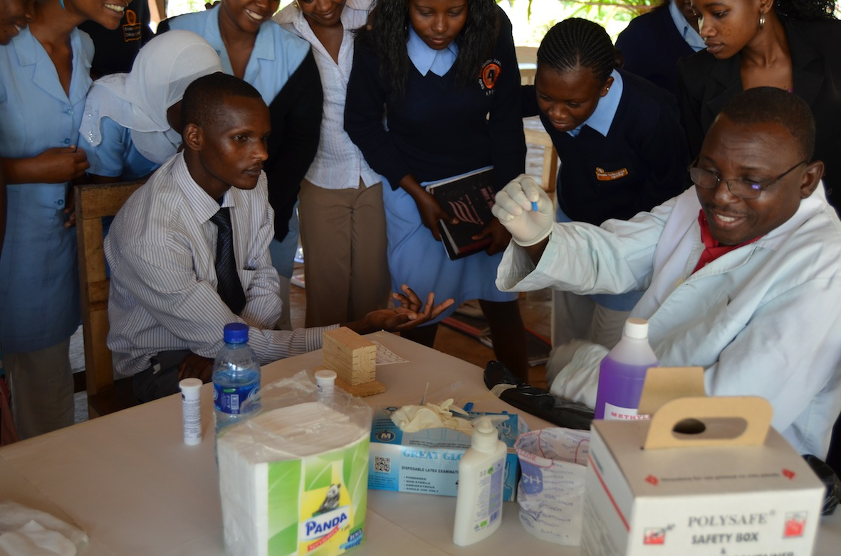

Both our tutors and third year students completed the HTC Course, which was given by NASCOP.

The participants were happy to receive this important course and are now ready to assist the community at large.

The rate of HIV/AIDS infected Kenyans currently is 0,9% for children between 0-15 years and 5,6% for people from 15 to 64 years old.

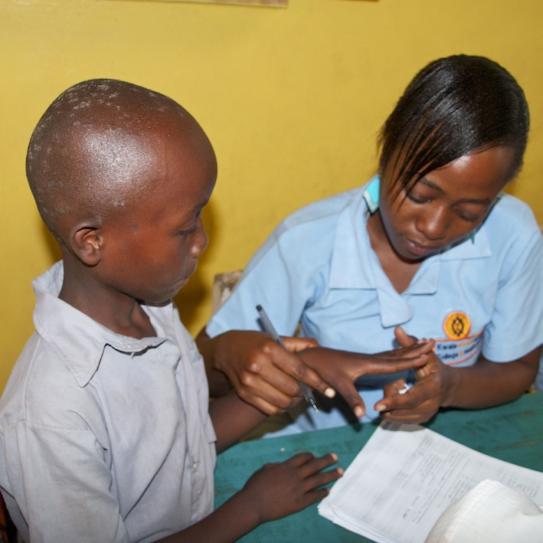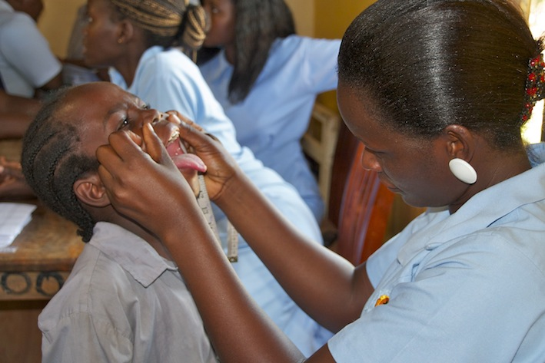**MEDICAL ASSESSMENT DESTINY VISIONARY PRIMARY SCHOOL – NOVEMBER**

We also carried out a medical assessment in a school in Likoni, where we have screened 234 children.

Almost 45% of the children were having worms and skin conditions, 25% was suffering from cough with a family history of TB. 10% was having Ear Nose and Throat problems and 10% had urinary tract infections. The other 10% of complaints we treated were asthma, allergies, wounds and common colds.

---------------------------------------------------------------------------------------------------------------------------

**OCCUPATIONAL FIRST AID KENYA RED CROSS COURSE – NOVEMBER**

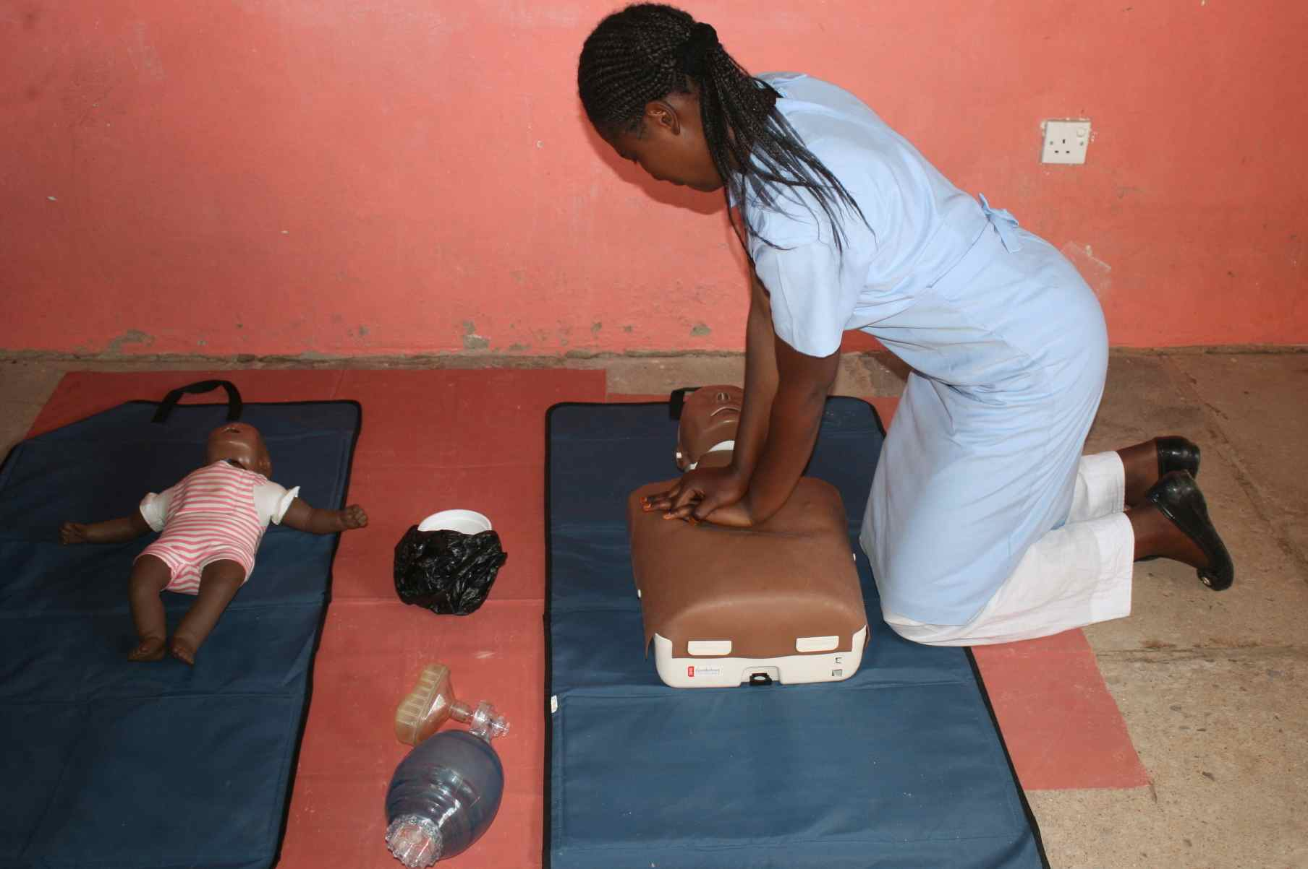All our 1st and 2nd year students participated in this intensive 4 day course.

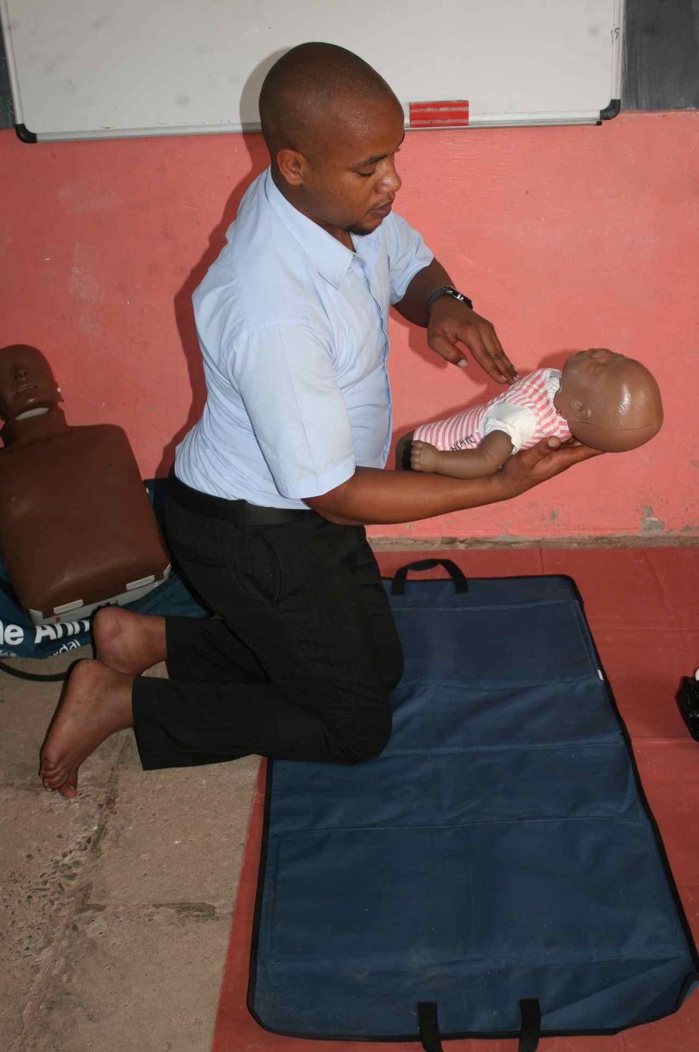

Our students were trained on life saving skills like how to deal with drowning people, fire incidents and injuries.

This is for the benefits of their life in and outside school plus the community at large.

**NUTRITION DAY – NOVEMBER**

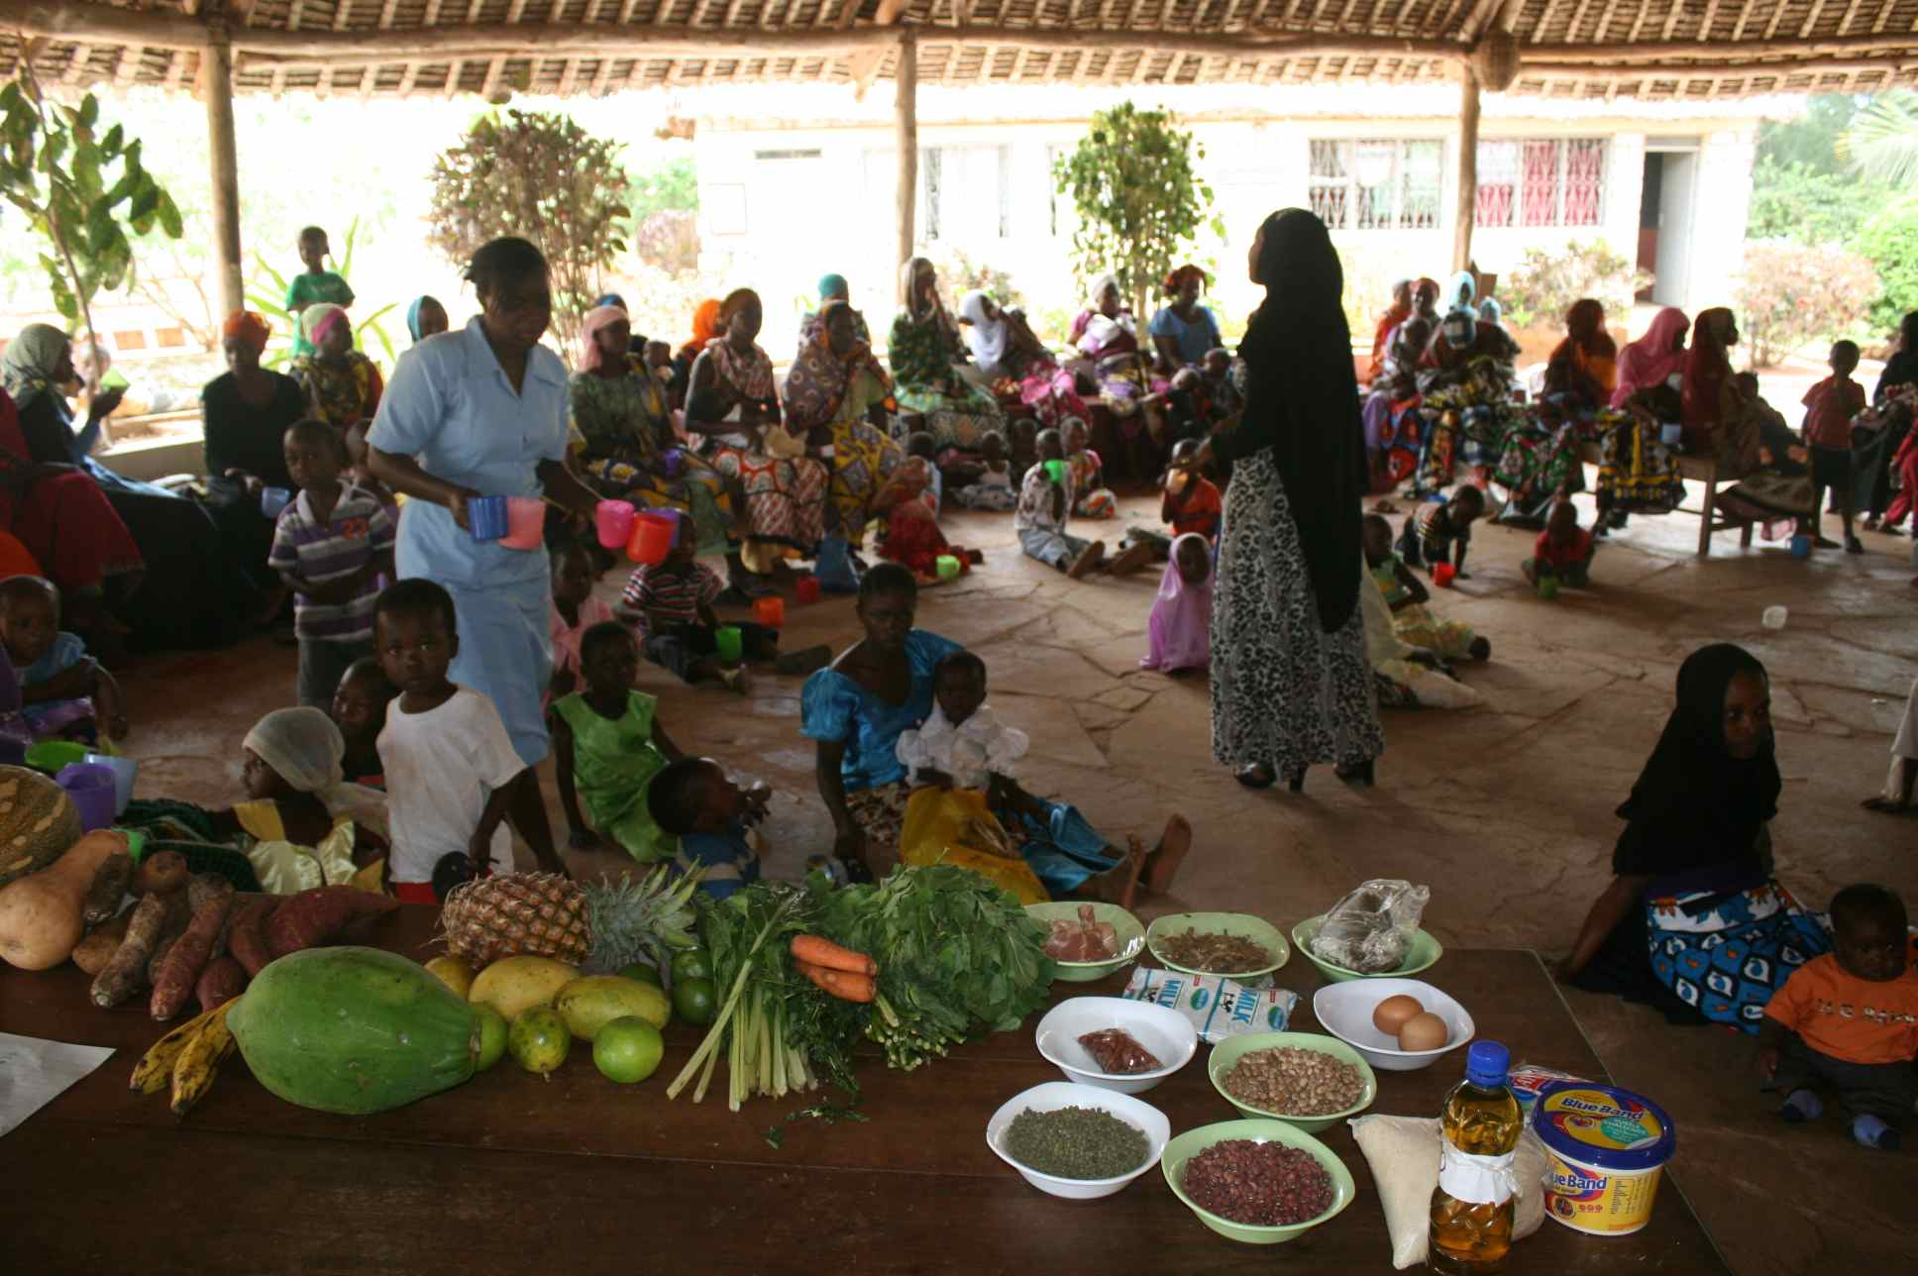From our experience we can conclude that on an average Nutrition Day about 22,5% children below 5 years old are suffering from malnutrition in Kwale County. During these days around 200 women and their little kids visit our Centre and are being trained by our Nutritionist on how to best feed their children. After we have assessed them we ask the often very young mothers to remain with their underweight kids, whom are given extra attention on homeopathic treatment. We also try to assist the needy mothers by giving them extra nutritious food for their weak children and ask them to return after 2 weeks in order to monitor them closely. It’s one of 4Kenia’s targets of 2014 to contribute to this alarming problem.

---------------------------------------------------------------------------------------------------------------------------

**CHARITY RUN ROTARY CLUB OF DIANI – DECEMBER**

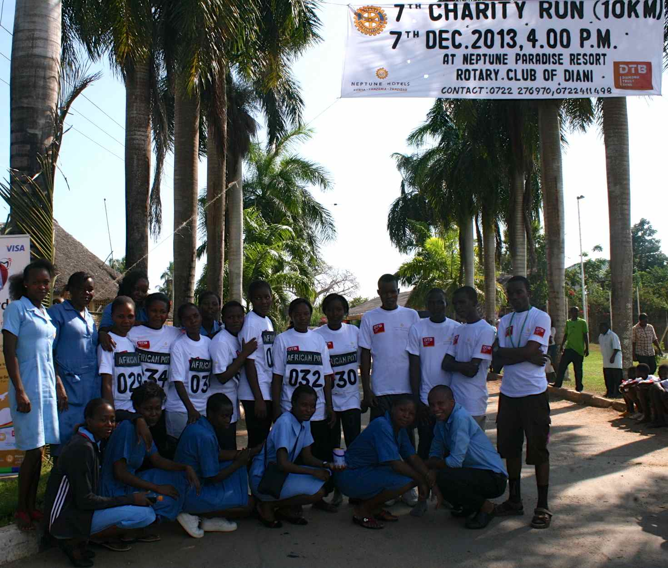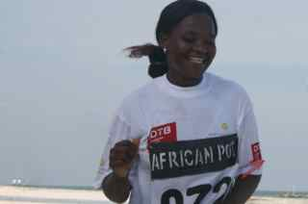

Together with our students we assisted the Rotary Club of Diani during the registration process of their annual Charity Run and of course we also had some runners including our homeopathic tutor Asia!

**ON OUR WAY TO SELF-SUSTAINABILITY....**

In September we could open our new shop due to the great donation of Joanneke Raadsen from LoFff who assisted us to buy our first inventory. With the various local goods and fresh vegetables from our vegetable garden, we are very happy to see that the shop is already self-sustainable after 3 months.

The Cafeteria hosted in August a busy 3-days seminar from the Ministry. In 2013 we will focus on more public events. These events are not only providing the Centre with some income, but also important to strengthen the cooperation with our local partners.

We are also assisting the Kenya Medical Training Students next door by offering them rooms in our beautiful hostel at the lower campus.

Currently we are also busy preparing for the realisation of our Community Centre next to the Cafeteria. This new facility will create a better opportunity hosting seminars, but also function as an IT Centre where we will start training young adults in basic computer packages.

With the raising costs of our monthly electricity bills, continuous power cuts which sometimes last for days and spoil many machines, we are exploring the exciting possibilities of how to implement solar systems.

These new developments should contribute to save on the monthly expenses and generate enough income in order to support ourselves in the near future.....

All help is highly appreciated and welcome!

---------------------------------------------------------------------------------------------------------------------------

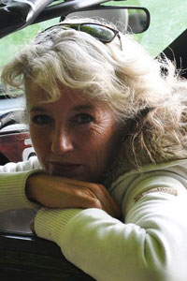**THANKS TO ALL SPONSORS!**

Without the wonderful support of many special people each in their own way, we would not be able to reach our goals. A big THANK YOU goes to our sponsors who support our students, volunteers, colleagues, relatives, friends, foundations, companies and private sponsors from 10 different countries!

* Terre des Hommes
* Wilde Ganzen
* Stichting Wanawa
* LoFff
* Stichting Lelystad Helpt Kenya
* Lamping JGL Advies
* Mousecraft
* Merlijn boekhandel
* World book of Value
* Hahnemann Instituut Nederland
* Richard Pitt
* Ministry of Health Kwale County

Joanneke Raadsen van LoFff

**And a special thanks to all our Silent Sponsors!!**

---------------------------------------------------------------------------------------------------------------------------