***5-Year Plan ~ 2019-2024***

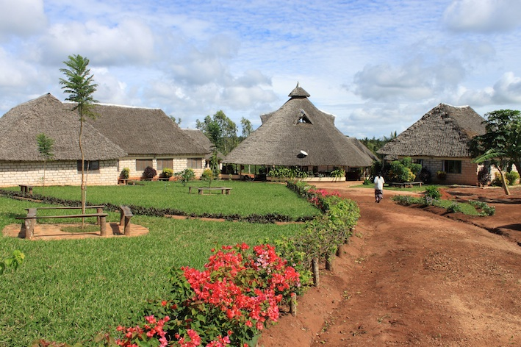

Kenya School for Integrated Medicine

P.O. BOX 147 – 80403 – KWALE

[info@4kenya.com](mailto:info@4kenya.com) * www.4kenia.com

## Vision

**To offer a unique education in Integrated Medicine and support the development of healthcare in Kenya.**

Kenya School for Integrated Medicine is dedicated to providing an excellent education and work opportunities for all who come to the school and improving the health and well-being of individuals and communities. It seeks to introduce the benefits of an integrated approach to health and its integration into the larger professional health community. It seeks to address the primary health care needs of both local communities and throughout Kenya through providing qualified health personnel, clinical outreach and research programs, supporting county and national community health strategy and through innovative digital health technology that assists in the development of health policy and strategies.

**Mission**

**To empower a new generation of healthcare practitioners with a quality medical education and through the integration of conventional and alternative medicines, to support the provision of accessible, affordable and effective healthcare for all.**

The production of a new generation of health care practitioners and leaders that can contribute to the needs of individuals and communities; the integration of health care modalities that can offer a comprehensive and diverse model of health care that can be an example throughout Africa; the self-empowerment of the Kenyan people in understanding the need for health preservation and awareness in their own lives and their families.

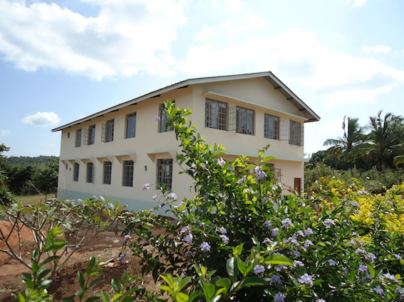

Strategic Areas of Focus

The plan defines five overarching strategic areas of focus that will decisively impact and influence achievement of the vision. The related statements are expressions of the fundamental aims of the institution over the next five years and help to channel our collective efforts in the development of major goals and strategies.

• **Education and Training:** Offering unique academic programs and sustaining the highest standards of academic performance and professional competence. The focus of the institution’s academic goals is to produce skilled health practitioners in areas needed in the community and that provide jobs for graduates, while also providing a unique, holistic view to the educational goals of the institution.

**• Clinical Excellence and Community Health:** Increasing the opportunity for access to quality integrated medical care, giving greater awareness and choice in conventional, traditional and alternative forms of healthcare. Providing health care choices through supporting mobile clinics in poorer and remote parts of the community and by actively supporting the government’s Community Health Strategy in elevating the health of the community.

**• Philanthropy and Public Value:** Growing philanthropy and effectively promoting the school’s unique public value through active working relationships with both governmental and NGO partners. By ensuring that the community value of the institution is recognized through its educational goals, its unique contribution to the community through its strategic partnerships, social programs as well as it’s educational opportunities for under privileged members of the community.

**• Outstanding Workplace and Operational Excellence:** Creating an exceptional work environment and fostering the highest standards of operational performance and financial transparency. Making the surrounding working environment at the institution an example of sustainable and holistic philosophy and in so doing creating a model working environment for the community.

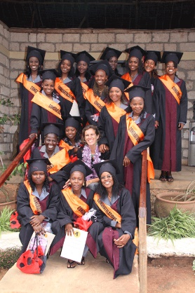**•** **Contributing a new generation of Kenyans to the workforce:** Creating independent healthcare practitioners who can be an example of a thriving, vibrant and successful professional community, developing a new level of health care professional. The introduction of a new cadre of health care workers, who is able to embrace a holistic and integrated view of health and understands the challenges facing communities and the need for a mre permament and sustainable solution to many health, environmental and social problems locally and nationally.

Strategic Plan Goals and major Strategies by Areas of Focus

**1. Education Training and Excellence**

**Offering unique academic programs and sustaining the highest standards of pedagogy; to pursue an academic vision that fits into a holistic and sustainable model for Kenyan healthcare needs. To be a leader in health education in the country in the curriculums being offered.**

* Continue to strengthen the Kenya School for Integrated Medicine, expanding pedagogical programs, focus on professional development, new teaching technologies and course evaluation methods.
* Modify academic systems and structures to enhance academic support services, bolster student advising and mentoring to comply with all accreditation standards.
* Undertake educational facility improvements to accommodate enlarged class sizes and new programs; expand small group learning/intellectual exchange spaces; provide technology enabled and virtual classrooms; expand the library resources; and provide optimal clinical department and graduate medical education office space. Augment internship experiences through new or expanded affiliation agreements with the local medical community, including medical and nursing colleges.
* Develop more part-time/online programs in Homeopathic Medicine and other holistic systems of thinking. To provide the opportunity for an exceptional and individualized learning process that would aid the development of the academic and professional competency of graduates and the whole homeopathic profession in Kenya. To explore partnerships to create a post-graduate diploma/degree program in homeopathic medicine for medically qualified personnel. To be a link between traditional and alternative forms of medicine through supporting research and education into all forms of medicine.
* To continue to develop learning methods and curriculum development using the best of modern technology; to become a leader in the area of Community Health training, as part of our commitment to national Community Health Strategy and the development of cadres in Community Health for the Ministry of Health.
* To be a leader in the area of Nutrition training through our certificate and diploma programs in Nutrition and Dietetics. To develop our own unique philosophy into the nutrition programs with a focus on sustainable food production methods, organic agriculture, holistic health modalities, preventative medical approaches, exploring issues of micro nutrient deficiencies etc.
* To explore the development and integration of other complementary and alternative systems of medicine into the program, broadening the scope of learning and creating a unique contribution to the development of health care options in Kenya.

**2. Research Excellence**

To explore the possibilities and potential of clinical research and experimentation of new medicines and research protocols relevant for the needs of Kenyans and Africans in general.

* To be a research knowledge source for the recognition of Traditional and Alternative Medicines. To integrate the foundational knowledge of Alternative Medicine research that originates from Europe and the United States, with knowledge of traditional medical practices in Kenya and the rest of Africa. To liaise with the government in using research to gain greater recognition and legitimacy for Traditional and Alternative Medicines
* To collaborate with other research institutions in Kenya and throughout Africa, seeking to define the scope and development of research opportunities on the continent in Traditional and Alternative Medicine
* To collaborate with existing international research organizations throughout the world that have developed protocols and methods of research into homeopathic medicine and clinical trials; to seek opportunities to collaborate with organizations in exploring the potential of this research in Kenya and beyond.
* To facilitate forms of research based on the results of clinical outreach programs and integrate the outcomes and knowledge acquired into the world-wide community of scientific research. To continue doing research into the efficacy of the Community Health Systems established through the institution, in partnership with the Ministry of Health
* Continue to upgrade research facilities and expand computational capabilities. To continue to develop the digital technology available that can assist in the types of research being done.
* To utilize the best possible faculty and staff for all subjects, that will add to the caliber of teaching and academic excellence.
* To collaborate with other Kenyan medical and research institutes in developing significant research to broaden knowledge of Alternative medicines and offer new medical approaches for the needs of Kenyans.

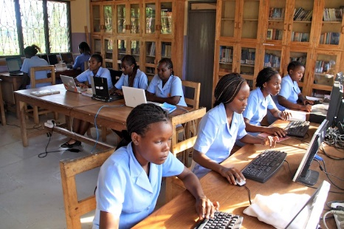**3. Clinical Excellence and Community Health**

**To focus on developing the best practice methods and professional competencies of all graduates; to support the development of clinical facilities that offer clinical experience as well as offering needed health services in the communities, particularly underserved poor and rural communities.**

* To explore all opportunities for the integration of homeopathy and other traditional and alternative medicines into existing clinical networks and facilities.
* To develop outreach clinics for graduates and students to gain vital clinical experience.
* To develop an economic model to allow graduates to make a living practicing their skills in the community.
* To facilitate the education of the general public into the benefits of homeopathy and natural health options.
* To liaise and work with other medical practices and institutions, to develop awareness of an integrated approach to health care issues.

4. Philanthropy and Public Value

**To share the unique benefits of the Kenya school of Integrated Medicine to the larger community; to promote the community value of the institution through its educational programs, its Community Health support through the national Community Health Strategy, its partnerships in the community, its outreach and social programs as well as its educational opportunities**

* To be a source of information for government and the private and civil society sectors seeking information, knowledge and awareness of homeopathy and Natural Medicine at large.
* To be an active and effective partner for the Ministry of Health and other government and NGO’s in supporting the community in Kwale County in all ways.
* To maintain a world-wide network of supporters and benefactors seeking to support the school.
* To further develop links and gather support from non-governmental organizations seeking to support the medical and health needs of the Kenyan people.
* To be a spokesperson and advocate for the world wide philanthropic community to the health care needs of people in Kenya.
* Strengthen brand recognition and public awareness of the school’s unique academic position, scientific advancements and community contributions.
* Engage consultants to restructure the Web site, leverage social marketing tools, and produce a new brand identity program.
* In partnership with other institutions, position the Kenya School of Integrated Medicine as a leading collaborative force in community and economic development for the surrounding community.



5. Outstanding Workplace and Operational Excellence

**Develop an optimal working environment for all faculty and employees, enhancing a professional and personal environment in which the best work practices and accountability is developed and maintained; to be an example of responsibility and integrity in the workplace for all engaged in the School.**

* Design and implement a more coordinated and consistent approach to job orientation and training, professional development, and succession management.
* To establish a program to incentivize all faculty and workers, to encourage and honor all employees who show they excel and make vital contributions to the institution.
* To ensure all staff and faculty are paid a wage commensurate to the work they do and offers the stability and support needed to live and support a family.
* To complete a comprehensive review/revision of institution-wide policies and procedures and implement an improvement initiative, focusing on achieving an optimal environment conducive to the high levels of performance needed at the school.
* Create an information technology organization and knowledge access environment that that optimally supports the educational, clinical, research, community health and administrative support programs and functions.
* Expand technical expertise, resources and leadership in the areas of research information and health information technology.
* Upgrade operational databases and academic, administrative and clinical management applications to provide enhanced functionality and improved reporting, analysis and decision support capabilities.
* Maintain contemporary facilities and promote a safe and secure work environment. To explore and research a 10 year program to overview the facility needs of the school and plan building and infrastructure improvements for the future development for the school.
* To offer a harmonious, environmentally safe and pleasing environment to work, one which allows all workers and students to work and study in a beautiful environment.