**KENYA SCHOOL FOR INTEGRATED MEDICINE NEWSLETTER**

Year 8, number 16, July 2013

Dear all,

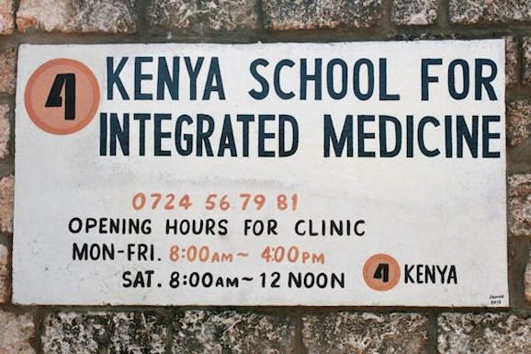It’s high time to update you on all the new developments. Starting with our new name: Kenya School for Integrated Medicine!

Since we have added new subjects like; Midwifery, Nutrition, Nursing procedures and the HIV/AIDS Training and Counselling Course, we believe it covers much better our Curriculum.

All first years have passed for their biking exam and the second years did their 8-day swimming course. The third years are currently all busy with their Driving Course.

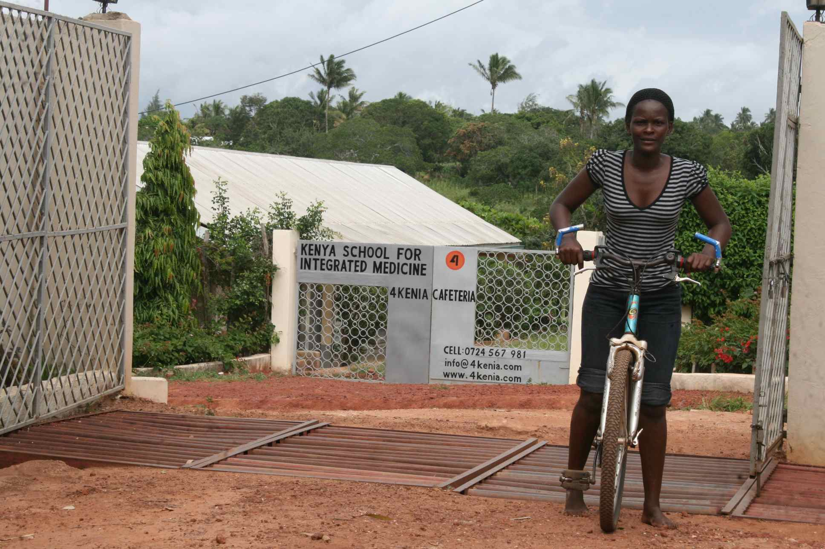This week all students have been sitting for the end of second semester exams and the third years are preparing their 8 cases for the oral exams of October. We are looking forward welcoming back Nursing Dean Mrs Patricia Donnachie and Doctor Noel Thomas, who will be assisting us with the oral examinations.

We believe our third years will do very well due to the fact they have been able to gain practical experience during their internship, where they rotated in 5 hospitals and 2 homeopathic clinics.

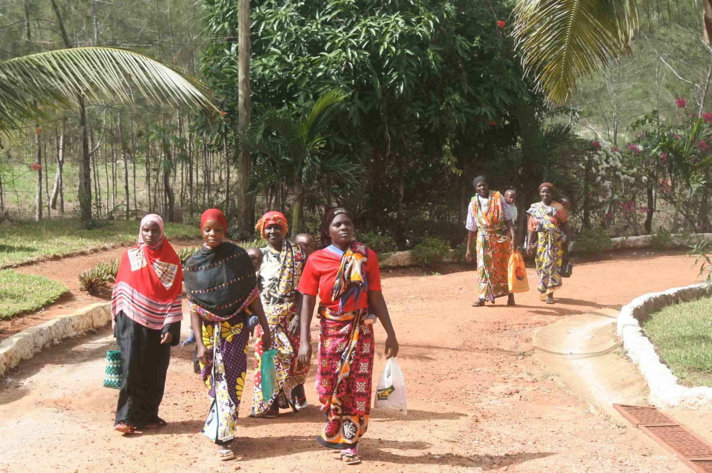We are very happy with our new partner Terre Des Hommes! They will be supporting 4Kenia for the next 2,5 years. With this wonderful partnership, we are able to assist many young children and mothers with their health during our mobile clinics. We can also continue to support hundreds of women who already came with their babies on their back (see picture) to our interesting Nutrition Days.

4Kenia will also be able to send our team of 6 permanent tutors to Nairobi for an intense 10 weeks pedagogical training.

On behalf of my Board, students and staff, I wish to thank you for your wonderful support!

Marie Magré, team & students

**OUTREACH CLINICS AT KWALE PRISON**

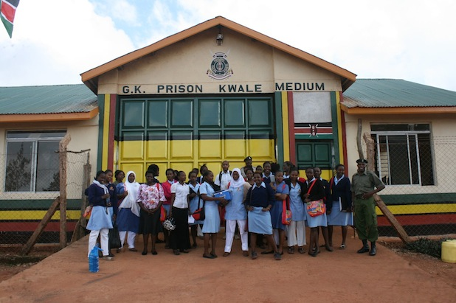

We have been carrying out several outreaches with our students and homeopaths to Kwale prison, which is only a 15 min walking distance from our Centre. It has been very interesting because of the diverse pathology they are often suffering from.

Due to the tough living conditions, we have treated many prisoners for serious skin diseases. Before we are allowed into the main gate, there are strict protocols for safety precautions.

The prisoners responded well to our treatments and are very open to talk about both their mental - and physical complaints. No need to say there is a huge difference between being in a European prison, where prisoners sleep in beds and often even get to watch television compared to the situation in Kwale.

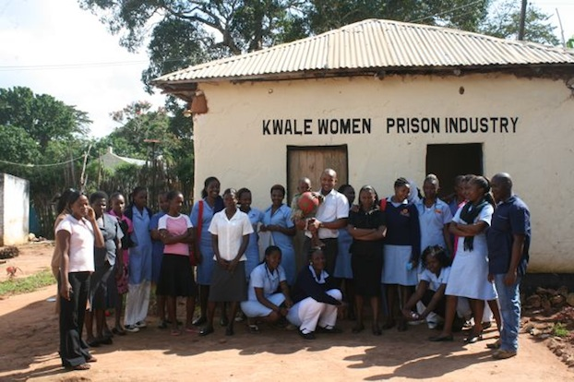

**NEW INTAKE STUDENTS & CALL FOR SPONSORS**

We have done many interviews for the new intake and selected already 15 new students, who will be joining the new academic year starting on Monday 23rd of September 2013.

Due to the fact that the College is growing and getting more known within a wider public, we are having more applicants who wish to join.

All teachers were actively involved taking interviews listening to the needy stories, motivation and dreams. Several students had been sitting in a bus for a whole night with only a one-way ticket in their hands. They had either received a loan from friends or a relative had collected money for their travel expenses in church. When they reached Kwale completely exhausted and hungry the following morning, it was so touching to see how determined they are to fight for a chance of being given the opportunity to get education.

If we can find enough sponsors, we would love to start with a new year of at least 30 students. You could assist us in giving them a chance by choosing from below options which sponsorship suits you best. You can even share your sponsorship with friends or colleagues!



* Registration fee is only applicable for first year students: ID, Computer Lab & Library, Educational trips and medical fee from 4Kenia clinic
* 4Kenia sends by mail to all her sponsors yearly one invoice, which can be paid either at once, quarterly or monthly
* We are a registered NGO and have the Dutch “ANBI Status” which makes your donation tax deductible
* Please write a mail to: [marie@4kenia.com](mailto:marie@4kenia.com) if you have any questions or like to receive more information

---------------------------------------------------------------------------------------------------------------------------

**4KENIA CAFETARIA**

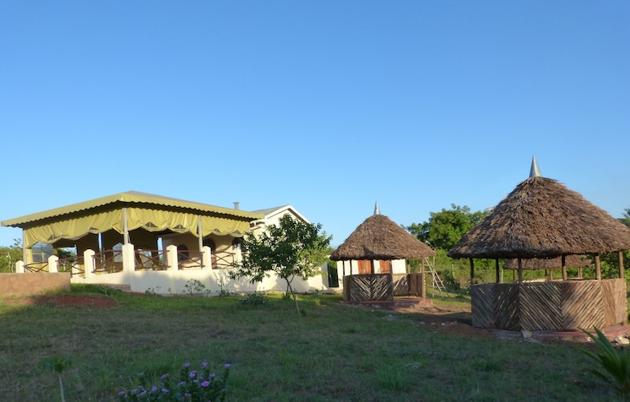Since February we have started using our Cafeteria at the lower campus.

It is slowly gaining name within the Kwale Community and becoming popular as a hide-away because of the three “kibandas” where office people like to have their meetings. With the beautiful views on the green Kwale hills, it’s certainly a “must” to taste our African or European dishes!

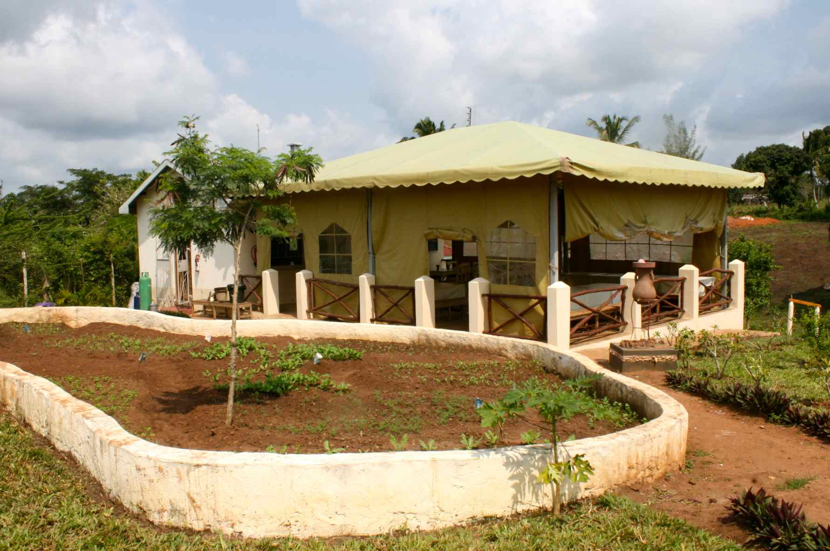

In front of the Cafeteria we have started a herb garden with dill, basil but also rucola salad and coriander. Kenyan soil is very fertile and therefore it’s a great pleasure to have your own veggies, especially during rain season where water isn’t a challenge like it usually is in the long dry season!

---------------------------------------------------------------------------------------------------------------------------

**VEGTEBLE GARDEN**

We have doubled our passion fruit plantation in size and this week sold our first 100 kg of local spinach “sukuma wiki”, as the tomatoes are now ripening and slowly turning red.

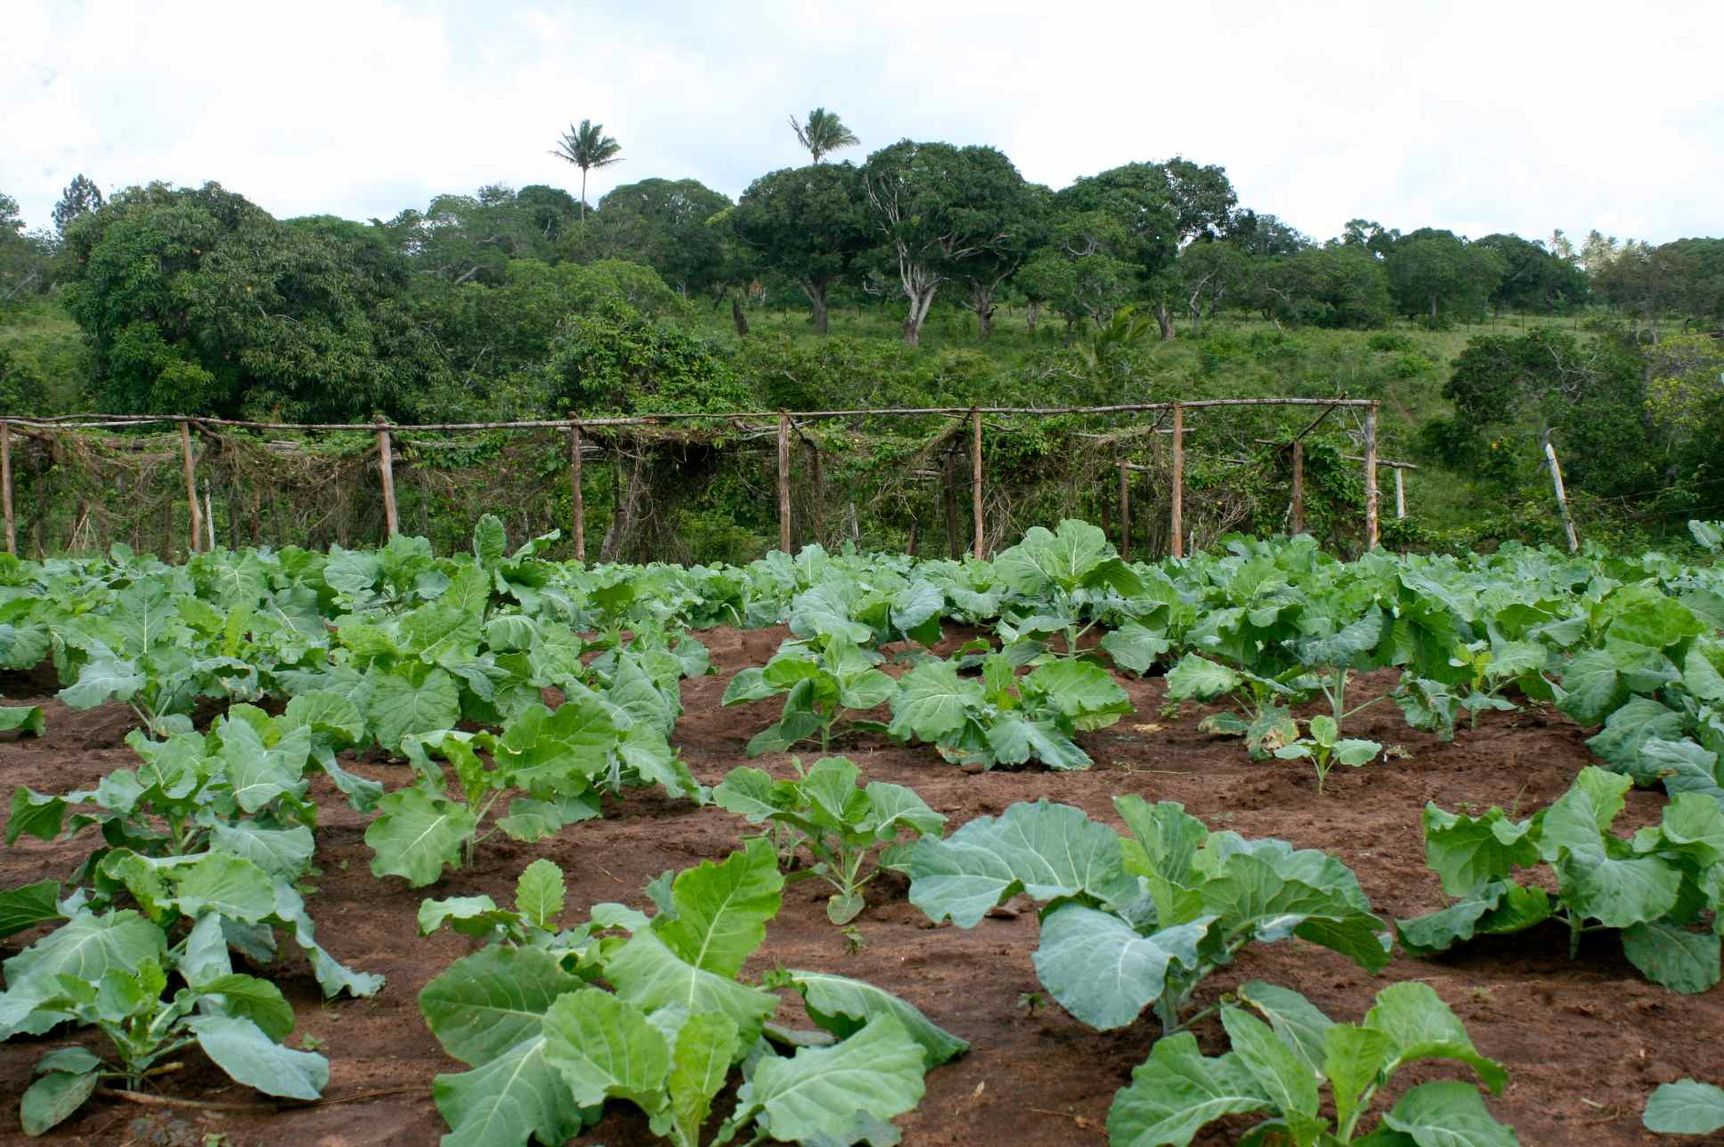We also have spinach, onions, eggplant, paprika, watermelon and pumpkins.

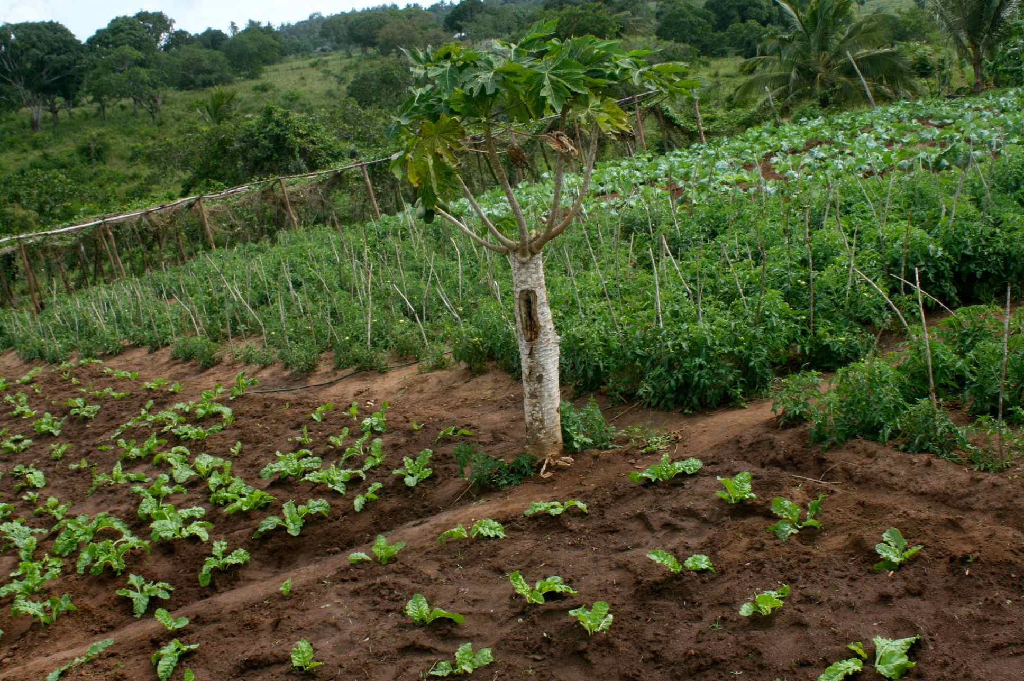

*Sukuma wiki* *Spinach and tomatoes*

---------------------------------------------------------------------------------------------------------------------------

**MOBILE CLINICS**

From 15th October we will be going out with both our first – and second year students to Shimbahills, Tiwi and Perani. We have asked our graduates to assist us during these busy days and we’re proud to cooperate with them! Each group will exist of 4 first years and 4 second years. Depending on the turn-up of patients, we will be treating between 3-5 days on each location. We are all very excited and hope to reach out to hundreds of needy people in these remote areas.

--------------------------------------------------------------------------------------------------------------------------

**BASKETBALL AND FOOTBALL PLAYING FIELD**

Every afternoon from 4-6pm we have our shade full of Kwale girls high school students playing table tennis and badminton, as others are actively playing football and basketball at the lower campus.

Friday 12th July we had our own students competing against each other and it was a lot of fun to see them struggle tall wanting to win one of the sweet prices.

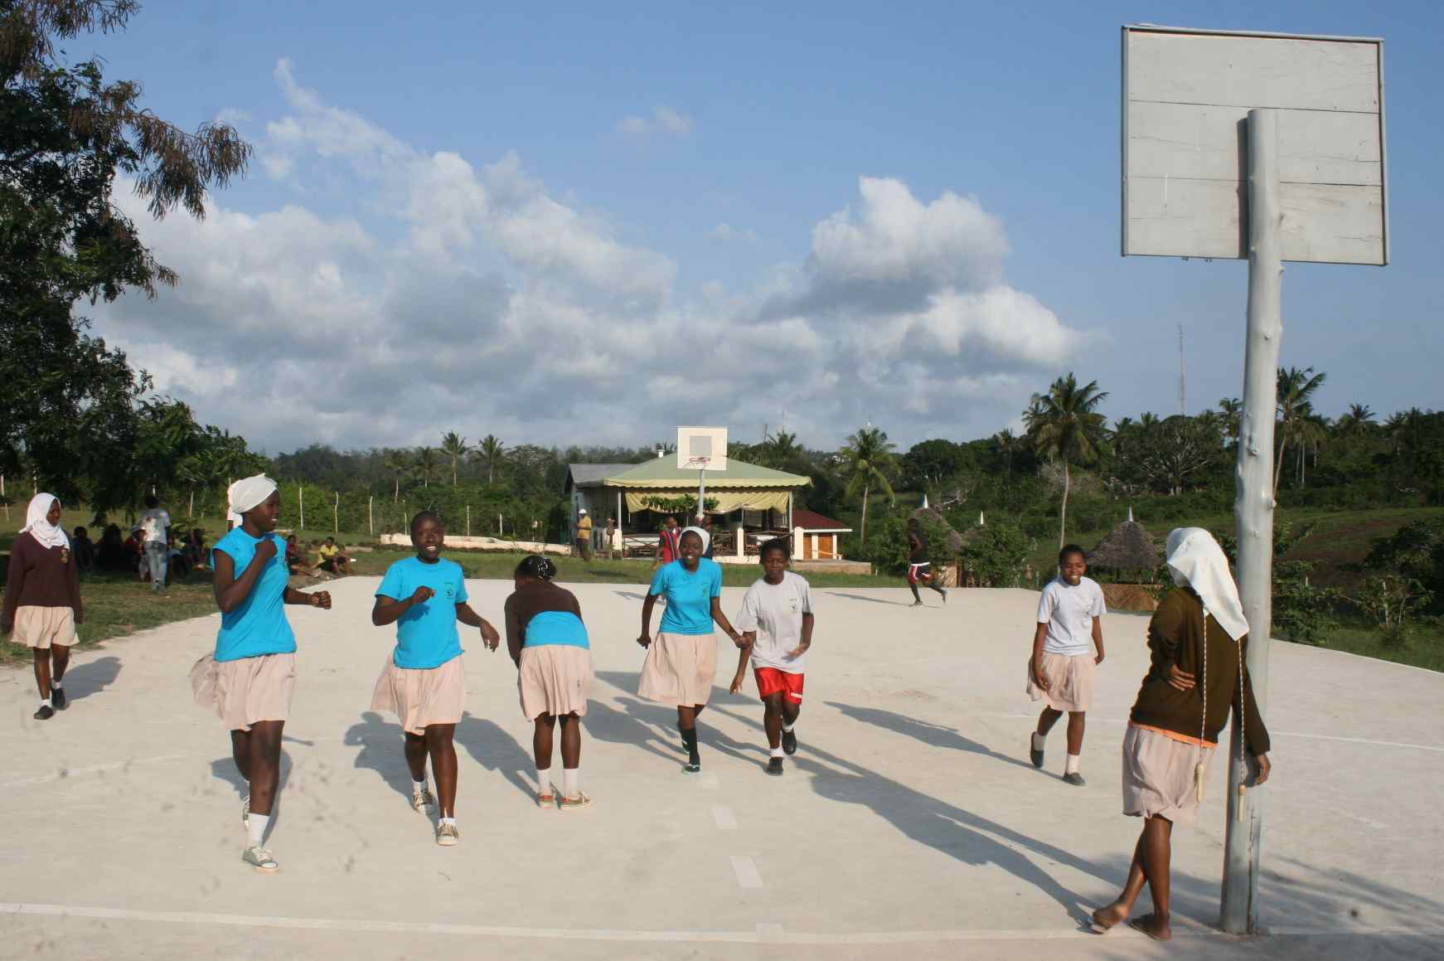We had lunch together with all staff at our own cafeteria. All students are done with their final exams and have relaxed their muscles in order to be fresh on Monday when we kick off with our exciting mobile clinics!

**OPENING 4KENIA SHOP**

The reorganisation has already borne fruits as we can see the splitting of all departments working well. We have turned our old cow barn into a beautiful 4Kenia shop. From August onwards we will be selling fresh veggies straight from our “shamba” and eggs from our 70 “kukus”.

We will also start selling water to the local community, who otherwise need to walk far in order to find clean water. It’s encouraging to hear how excited our staff, students and locals are about this new initiative. We are aiming to make it self-sustainable and hope it will be able to contribute to the School in the near future.

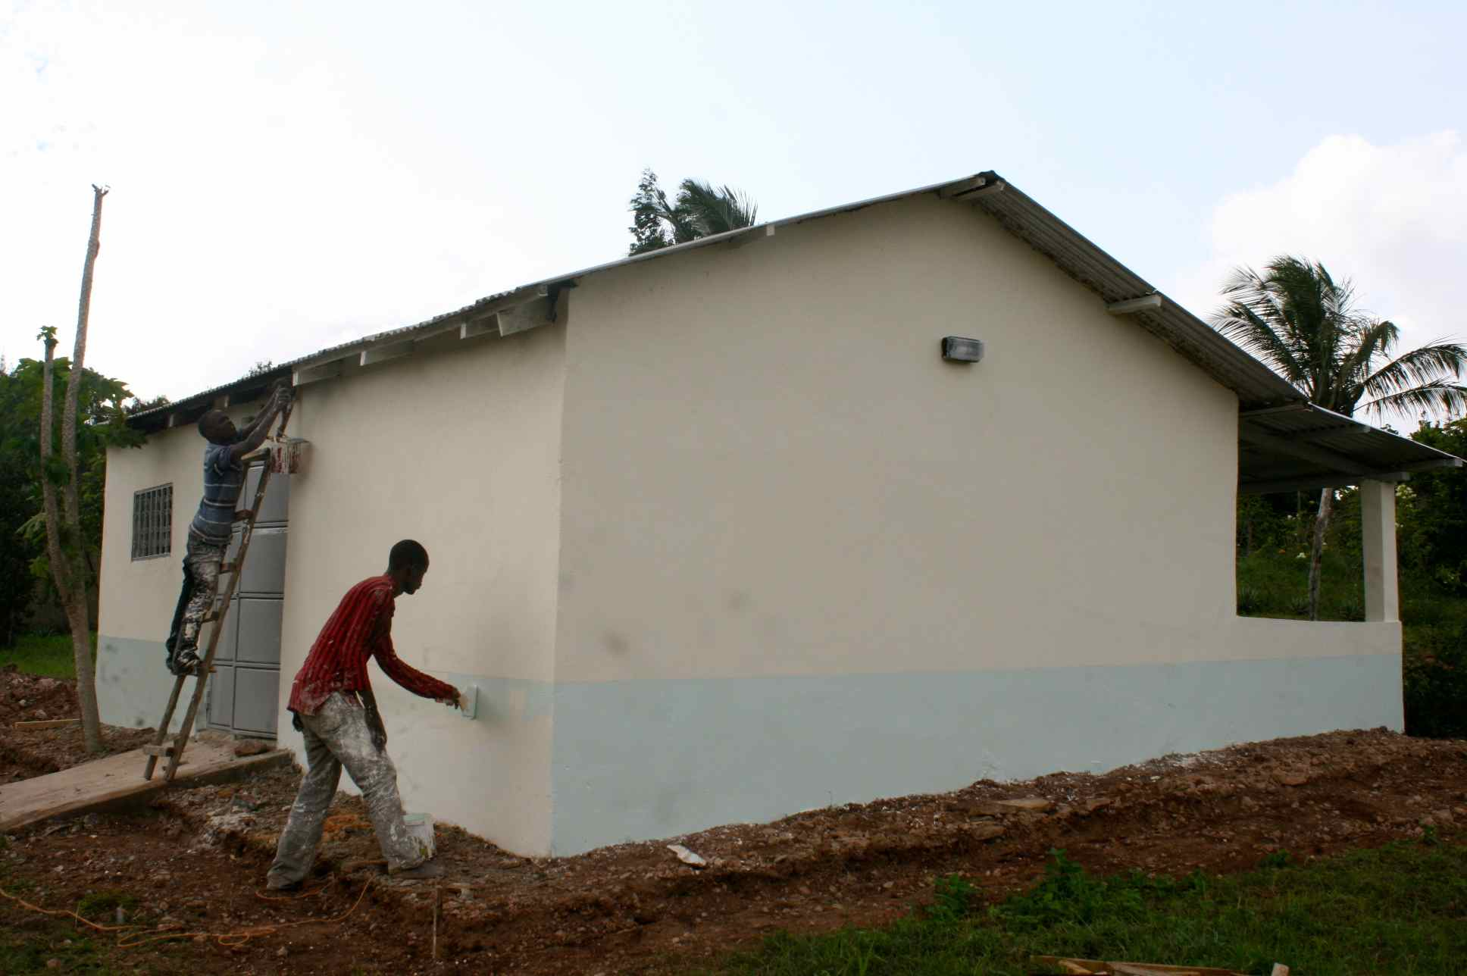

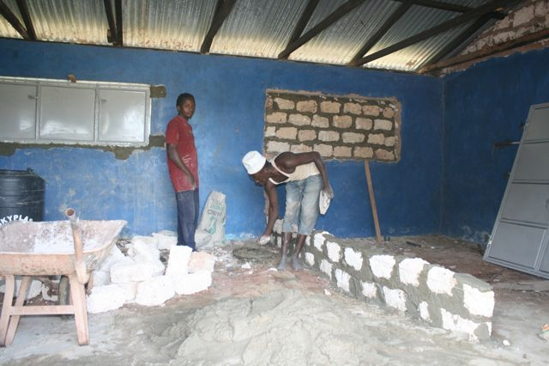

*Before…. After…*

--------------------------------------------------------------------------------------------------------------------------

**THANKS TO ALL SPONSORS!**

Without the wonderful support of many special people each in their own way, we would not be able to reach our goals. A big THANK YOU goes to our sponsors who support our students, volunteers, colleagues, relatives, friends, foundations, companies and private sponsors from 10 different countries!

* 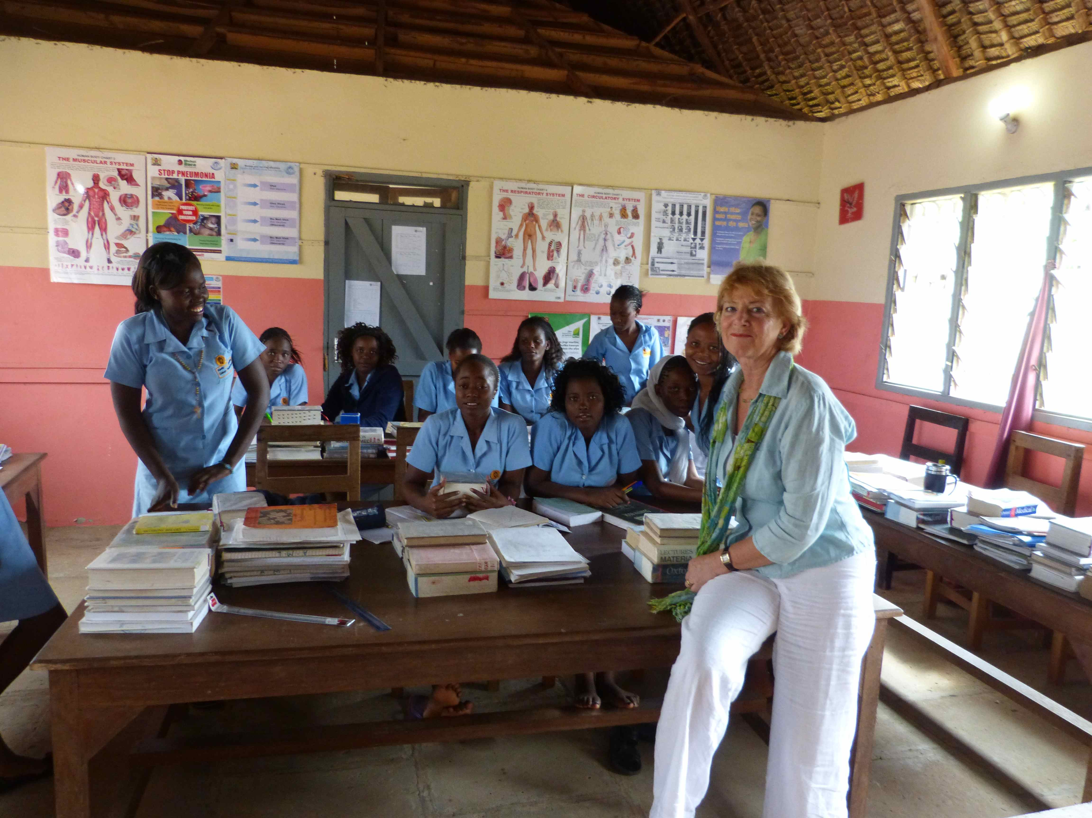Terre des homes
* Stichting Henriëtte Fonds
* Stichting Wanawa
* Stichting De Ziekenfondsbode
* Stichting Lelystad Helpt Kenya
* Lamping JGL Advies
* Mousecraft
* Merlijn boekhandel
* World book of Values
* Velo en Co
* Marie Somers
* De heer en mevrouw de Jong
* Frank & Stephanie
* Elise & Frank
* Richard Pitt *Annelie Smits*

---------------------------------------------------------------------------------------------------------------------------

**SATURDAY JEWELRY PROJECT STUDENTS**

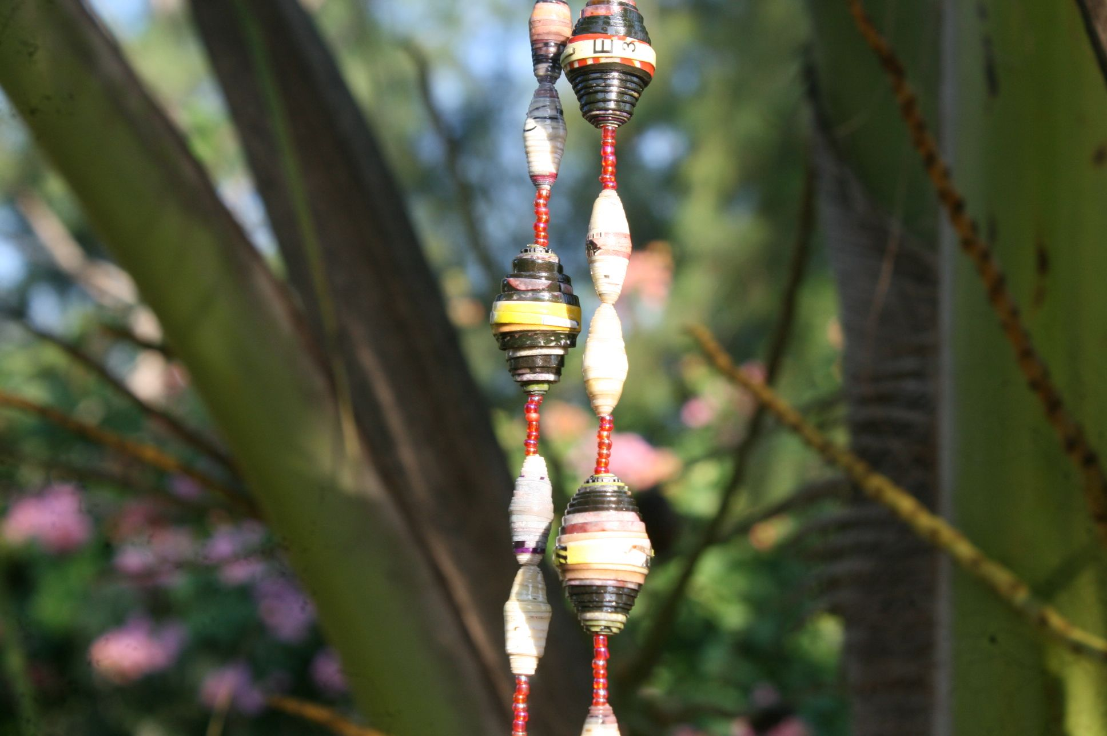

The students have started making new jewelry from old calendars. These paper necklaces are a wonderful gift!

The average selling price for a big necklace is 1,000, = KSH (= 10,- euro) and for a smaller one it’s 750 KSH (= 7,50 euro).

With the profit they are able to pay for their own Driving classes and when the budget allows it they will be able to start buying medical books and remedies.

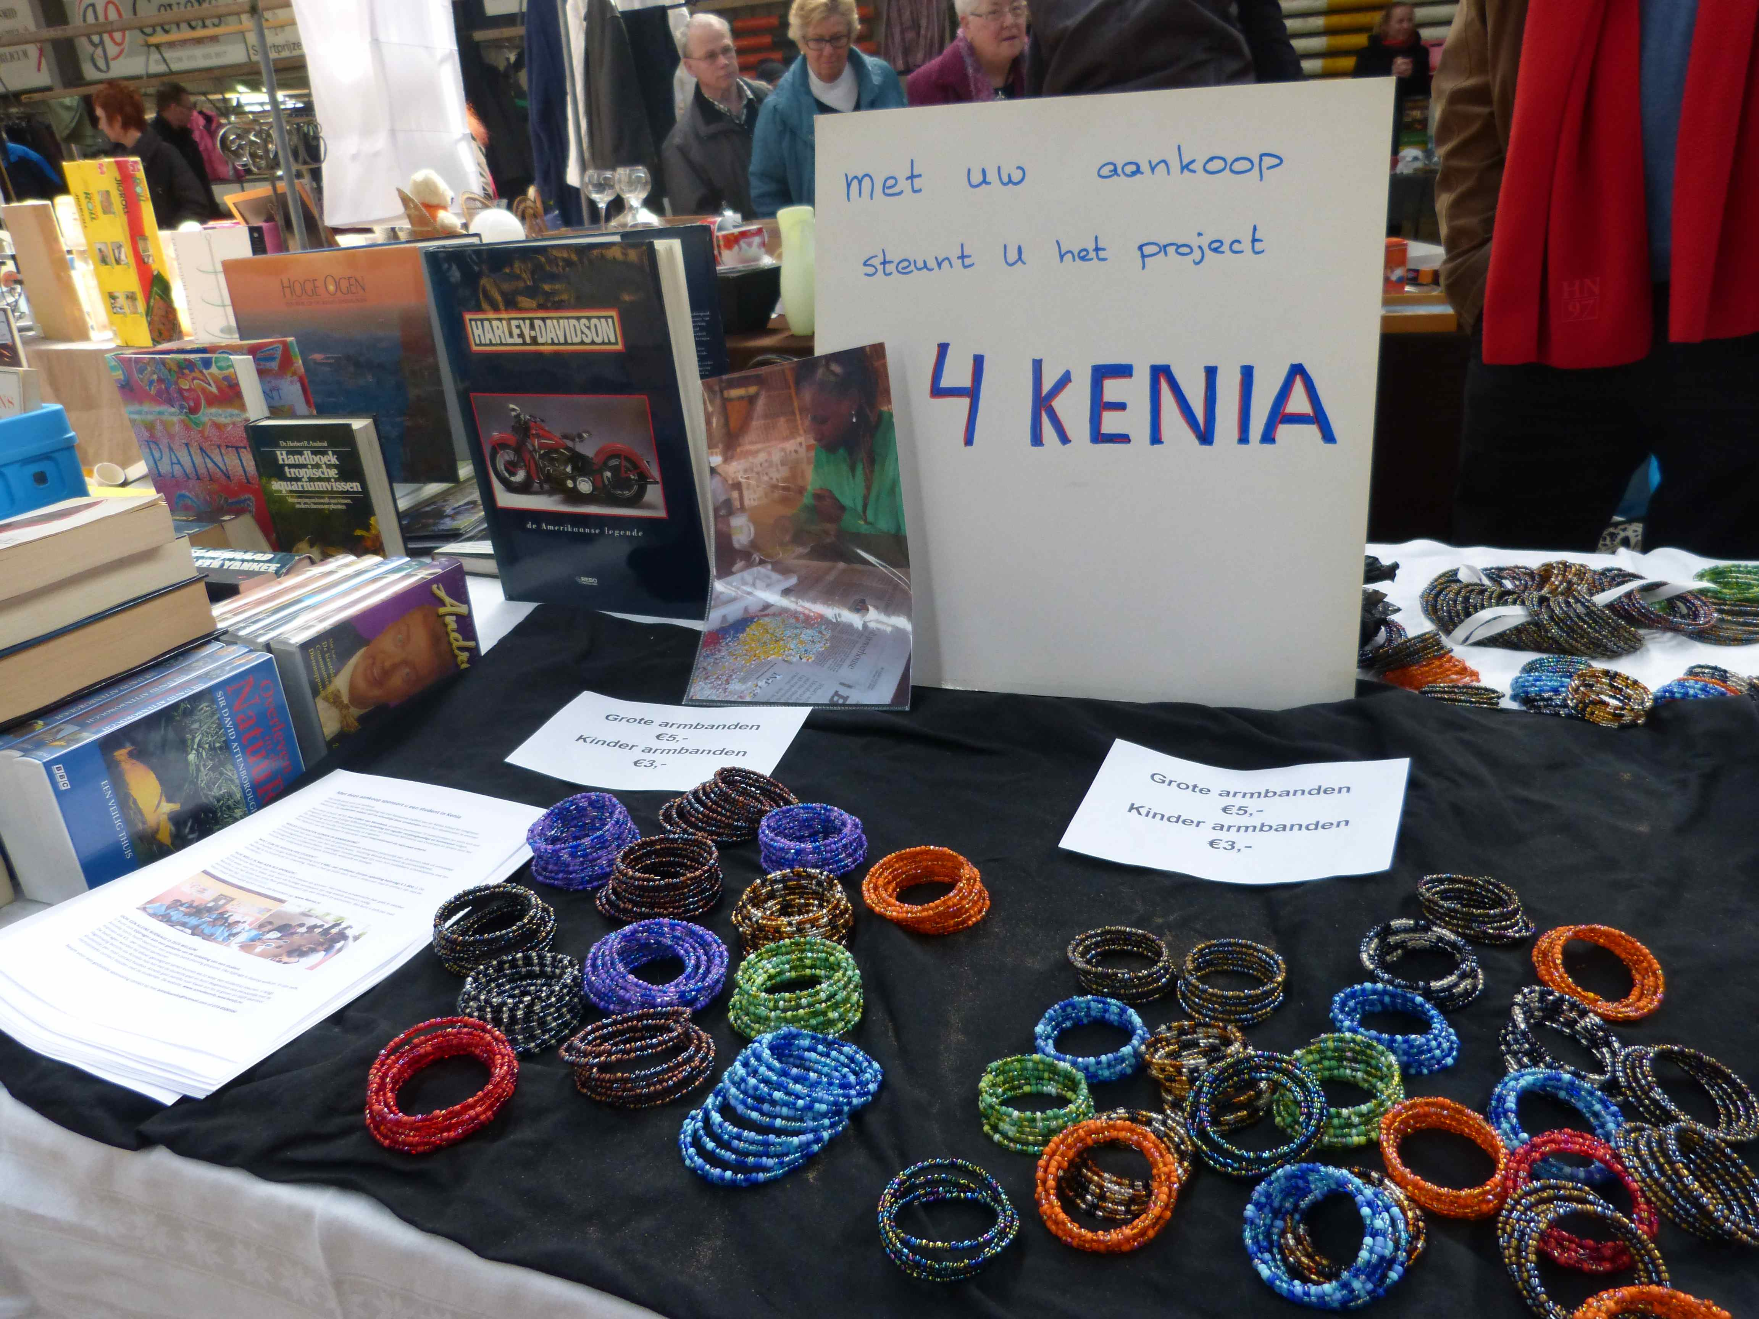

Our students will appreciate your orders and be pleased to make them especially for you!

If you wish to place an order you can send a mail to: marie@4kenia.com.

Annelie Smits has again promoted our students by selling their bracelets at a Dutch market: asante sana!